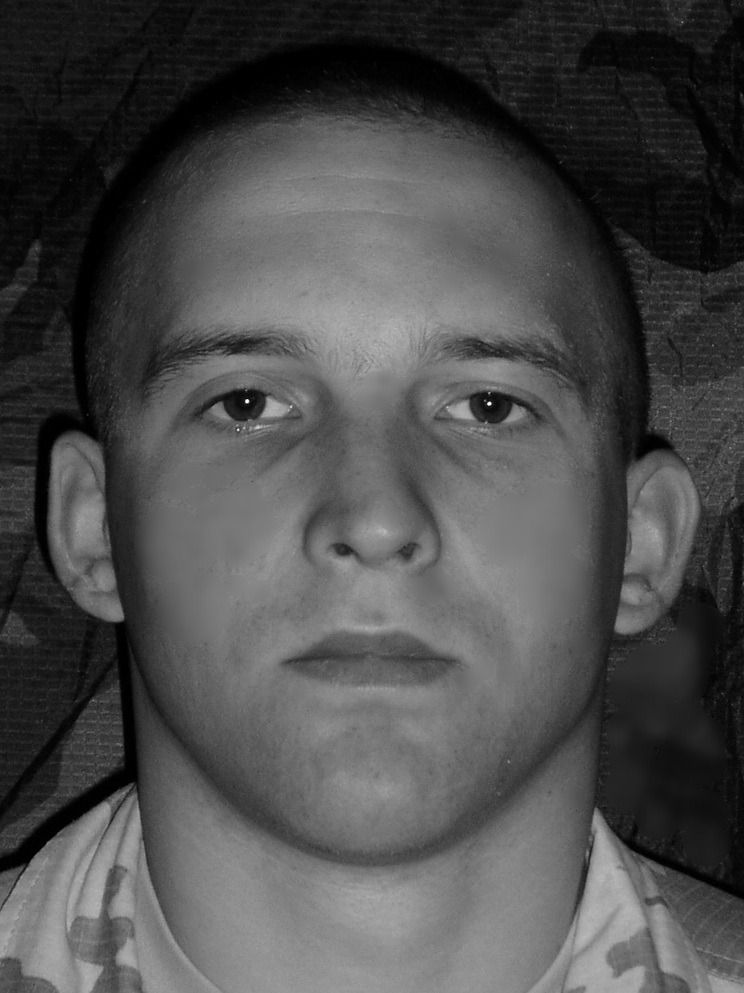
TOMAS STACKUNAS
101 Garrick Close, London, W5 1AT
Mobile: 07895609491; E-mail: tomasstackunas@gmail.com

Personal information

Mobile: 07895609491
E-mail: tomasstackunas@gmail.com
Date of birth: 26/04/1983
Nationality: Lithuanian
Work status: EU citizen (no work permit required)
Interests: Sport (martial arts, football, basketball, athletic), literature, traveling.

Employment

2010- present Extra men Recruitment Agency(London)- Logictics Assistant
2008- 2010 Casino Tornado(Vilnius, Lithuania)- Security Guard
2007- 2008 UAB Eurocash1(Vilnius, Lithuania)- ATMs Cash Supplier, Armed Guard
2005- 2006 Mechanized Infantry Batalion of Mindaugas( Lithuanian Army Forces)- Infantry Platoon’s Section Commander
2004-2005 KASP(Lithuanian Army Forces)- Vilnius International Airport Armed security forces.
2002- 2004 Mechanized Infantry Batalion of Algirdas(Lithuanian Army Forces)- Machine Gunner

Education

02/2012 Dean training. SIA door supervisor an CCTV licences obtained.
2007 Vilnius Security Trainee Centre, Personal and wealth guardian course. Shotgun licence obtained.
1990- 2002 Vingis Secondary School, Vilnius, Lithuania (equivalent of UK high school).

Languages

Lithuanian- native
Russian- fluent
English- excellent communication skills, practical writing knowledge.

Other skills

T Proficiency: Word, Excel, Internet Explorer,
Excellent ability to detect problems and report information to appropriate personnel
Strong ability to maintain and follow safety procedures.
Outstanding ability to resolve customer's complaints.
Excellent communication and presentation skills.
In 2003-2004 and 2005-2006 was participating in International Military Peacekeeping Missions in Iraq as a machine gunner.

Additional information

Received medal of Ministry of Defence of Lithuania for international military mission. Also honoured with Danish colonel’s Friis’s medal for military march in Iraq.
I am responsible, honest, self-motivated, hard working and sociable person. During my previous work experience I have been able to quickly respond to all tasks and carry them with 100% accuracy. Ability to learn new things quickly and willingly.

